# Café Management System

### A MINI PROJECT REPORT

#### Submitted by

#### Group: G20

#### Project Group: PG16

**Purusharth Aggarwal, 2410991603**

**Ruhani Singal, 2410991624**

#### in partial fulfillment for the award of the degree of

## BACHELEOR OF ENGINEERING

***in***

CSE



**CHITKARA UNIVERSITY**

**CHANDIGARH-PATIALA NATIONAL HIGHWAY**

**RAJPURA (PATIALA) PUNJAB-140401 (INDIA)**

November, 2024

**TABLE OF CONTENTS**

|  |  |  |
| --- | --- | --- |
| **Sr.no** | **Section** | **Page no** |
| **1)** | **Introduction** | **1** |
| **2)** | **Problem Statement** | **1** |
| **3)** | **Key Features** | **1** |
| **4)** | **Technical Details** | **2** |
| **5)** | **Project Highlights** | **3-6** |
| **6)** | **Conclusion** | **6** |
| **7)** | **References/Links used** | **7** |

1. **Introduction**
   1. **Topic: Cafe Management System**
2. Welcome to our Café Management System,
3. Your ultimate partner in streamlining café operations and enhancing customer experience
4. Designed for both small coffee shops and larger chains, our platform simplifies order processing, inventory management, and customer engagement—all in one user-friendly interface.
5. With real-time analytics and tailored solutions, we empower you to make informed decisions and boost profitability. It will help you create a vibrant café environment where great service and delicious coffee thrive.
6. **Problem Statement**
   1. **CHALLENGES FACED BY CAFFES:**
7. Manual Order taking and processing
8. Inventory management difficulties
9. Customer data tracking limitations
10. Difficulty in generating reports
11. Therefore, we are creating a user-friendly website using HTML, CSS and JavaScript which will help in easily placing orders online
12. Its purpose is to manage the caffe management business more efficiently and effectively

1. **Key Features**
   1. **Main Properties of the Site:**
2. **Online Ordering**: Customers can place orders directly from the website
3. **POS (Point Off Sale)**: Efficient order management and payment processing
4. **Inventory Management**: Real time tracking of Stock Levels
5. **Customer Relationship Management**: Customer Data Collection and Analysis
6. **Reporting And Analytics**: Generate detailed reports on sale, revenue, and customer feedback
7. **Technical Details**
   1. **Fine Points of site:**

**HTML Components**

* Header: Logo, navigation links (Home, About us, Orders, Feedback).
* Main Content: Product listings, descriptions, videos.
* Footer: Contact information and social media links.
* We have used many different tags like button tag, br tag, paragraph tag, header tag, heading tags and bold tag

**CSS Styling**

* Layout: Use Flexbox or Grid for responsive design.
* Typography: Choose web-safe fonts or integrate Google Fonts.
* Colour Scheme: Define a consistent colour palette.
* Responsive Design: Media queries for mobile compatibility.

**JavaScript Functionality**

* Dynamic Content Loading: Use AJAX for fetching course data without reloading the page.
* Form Validation: Validate user input on forms before submission.
* Interactive Elements: Dropdowns, modals for product details or add-ons.
  1. **Overview of site:**

1. The Website is divided into 4 sections
2. The Sections are – Home, About, Orders, Feedback
3. It consists of a header which will easily help to navigate through the whole website and its components
4. The header also includes a search bar made using the search tag to search for the products in an efficient manner
5. It also consists of a “add to cart” option to view the items selected for order and do payments related to it
6. Here we use BUTTON tags to accept order from the customer

**5.1. Project Highlights**

**5.1. Login Page:**

**5.1.1. Benefits of login page**

1. **Personalization:** Users can access personalized content settings or preferences after logging in.
2. **Security:** It helps protect sensitive information or services by restricting access to authorized users only.
3. **Data Collection:** Login systems allow websites to gather user data for analytics and improve services.
4. **Authentication:** Ensures that only genuine users can access certain areas of site, reducing the risk of fraudulent activities.
5. **User Engagement:** By providing a login page, websites can maintain user engagement through saved preferences.

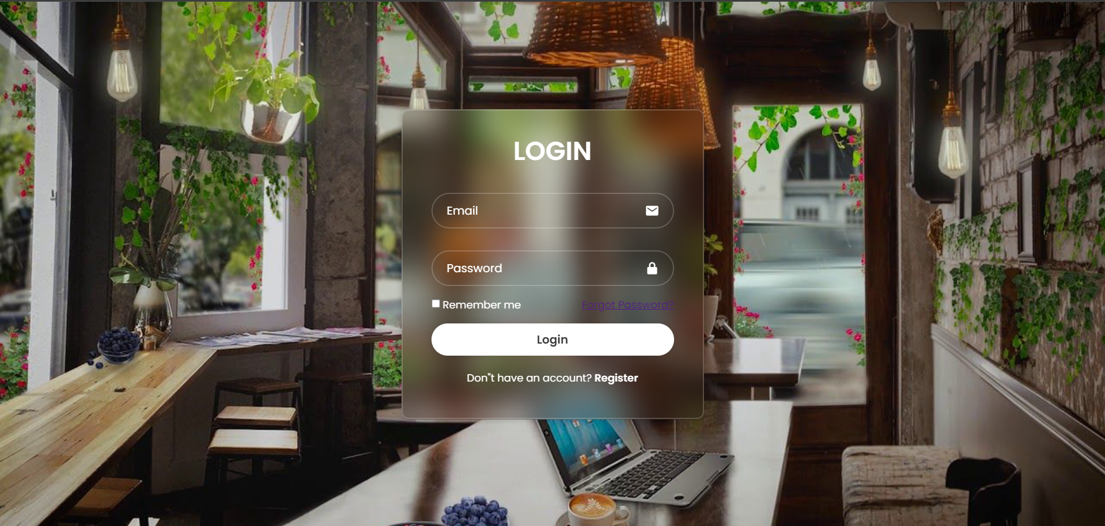

**5.2. Sign up Page**

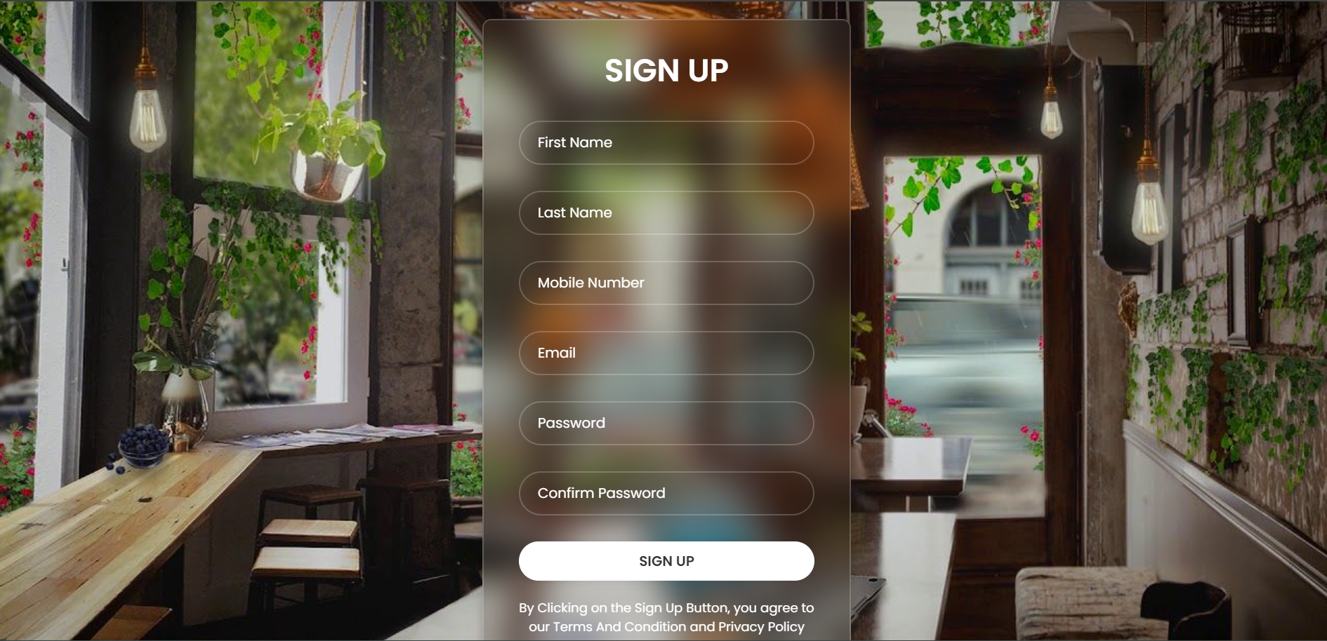

**5.3.** **Home Page**

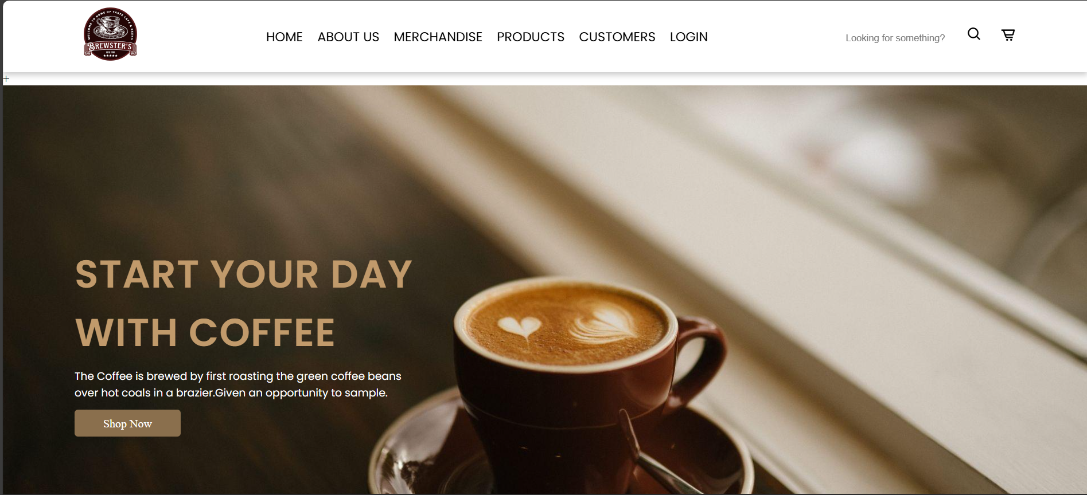

**5.4. Footer Section**

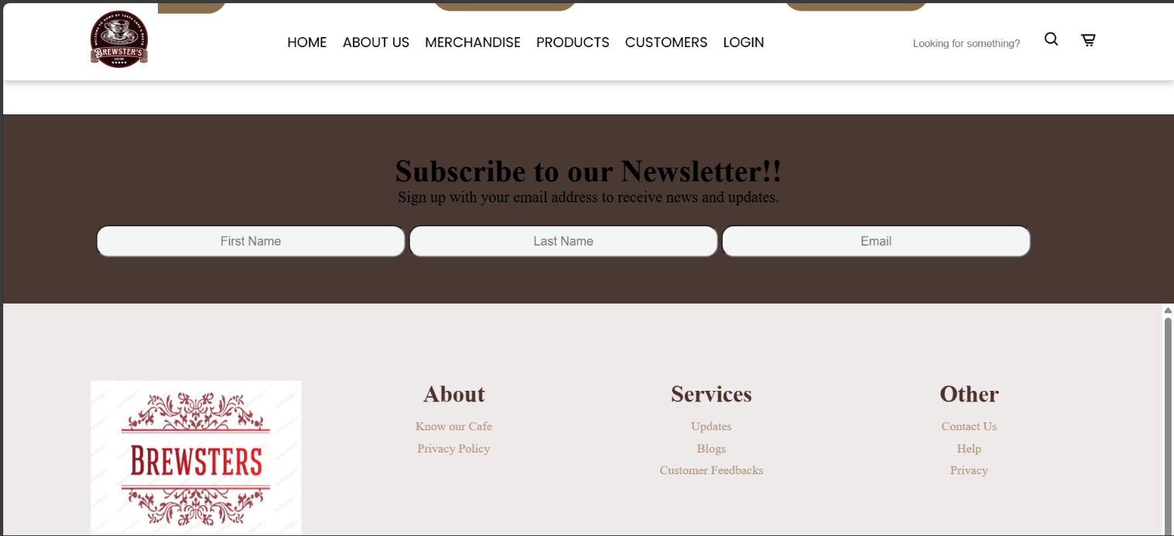

**5.5. Main Page**

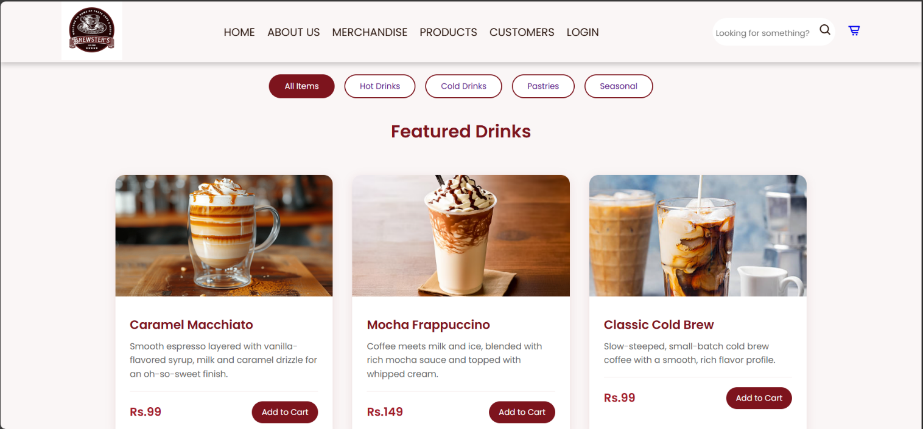

**5.6. About us page**

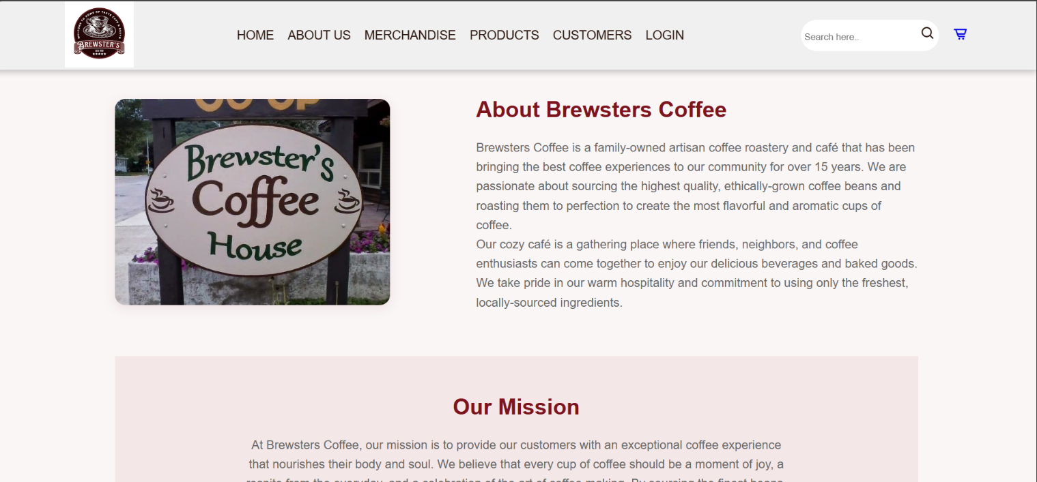

1. **Conclusion**

**6.1. Summary:**

1. This will help the business to stay competitive in a digital driven market as we are using modern methods to display our products online
2. It will also help us to reach to new customers through online methods
3. People can also know about the cafe before their visit so that they could know whether the place suites their desires
4. Customers can also contact us using the Contact Us column in the bottom of the webpage
5. Reference/Link Used
   1. **Referrals:**

1. [**https://www.geeksforgeeks.org/**](https://www.geeksforgeeks.org/)
2. [**https://www.logoai.com/logo-maker**](https://www.logoai.com/logo-maker)
3. [**www.google.com**](http://www.google.com/)
4. [**www.youtube.com**](http://www.youtube.com/)
5. <https://developer.com>